CONFERENCE OBJECTIVE:
The aim of the conference is to exchange experiences and views of scientists,business practitioners, representatives of business-related organizations as well as local government officials on the methods of developing cooperation between science and business.

PUBLICATION:
Positively reviewed papers will be published in the post-conference monograph published by WYDAWNICTWO NAUKOWE AKADEMII IM. JAKUB Z PARADYŻA, which, according to the Announcement of the Minister of Science and Higher Education from on January 18, 2019, 80 points were awarded

The condition of publication is the preparation of the paper in accordance with the editorial requirements. In the case of negative reviews, we do not refund the publication fee to participants. Editorial requirements can be found at: www.konferencja-swb.ajp.edu.pl

AMOUNT OF FEES *:
PLN 350 - participation with publication of a paper.

The fees should be paid by November 5, 2022, with the note "Name and surname SWB 2022" on account: Santander Bank Polska 13 1500 1416 1214 1001 0730 0000
Invoice details: Akademia Jakub from Paradyż,
ul. Teatralna 25, 66-400 Gorzów Wielkopolski,
NIP 1040001590

IMPORTANT DATES:
• Until October 31, 2022 – registration using the form available on the conference website: www.konferencja-swb.ajp.edu.pl
• By November 5, 2022 - payment of the fee
• Until 10 December 2022 - sending the full text of the paper and a signed declaration on the transfer of copyright by e-mail to the following address: konferencja.swb@gmail.com

VENUE AND DATE OF THE CONFERENCE:
The conference will be held on December 13, 2022 in the building of the Main Library of the Academy Jakub from Paradyż in Gorzów Wielkopolski at F. Chopin 52. For those who will not come to the conference venue on 13/12/2022, WE WILL ENSURE THE POSSIBILITY OF PARTICIPATION IN THE ON-LINE MODE (using the ZOOM platform).

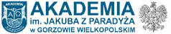

invite you to

XI International Scientific Conference

"EFFECTIVENESS IN BUSINESS"
under password:

"Cooperation between science and business as an opportunity for economic development"

DECEMBER 13, 2022

SCIENTIFIC COUNCIL:
prof. related dr hab. Janusz Soboń (Jakub z Paradyż Academy)
prof. related dr hab. Zenon Głodek (Academy of Jakub from Paradyż)
prof. related dr hab. Edward Urbańczyk (Jakub z Paradyż Academy)
prof. related dr hab. Eng. Józef Frąś (Poznań University of Technology)
prof. related dr hab. Eng. Ignacy Chrzanowski (Maritime University of Szczecin)
prof. Zdzisław Sirojć (University of Management in Warsaw)
prof. Dr. Edgar Klose (MITI, Strausberg)
prof. YuriKaragin (National University of Culture and Arts in Kiev)
prof. Andrzej Cwynar (University of Economics and Innovation in Lublin)
prof. Tatiana Varcholova (UCEU in Skalica, Slovakia)
prof. Ryszard Piasecki (Secretary General CIFE Nice-Berlin)
prof. extra dr hab. Joanna Rogozińska-Mitrut (Academy of Jakub from Paradyż)
prof. extra dr hab. Eng. Jerzy Rossa (Jakub z Paradyż Academy)
dr hab. Magdalena Byczkowska (Jakub of Paradyż Academy)
dr hab. Krzysztof Czyrka (Jakub z Paradyż Academy)
dr hab. Anna Majzel (Jakub z Paradyż Academy)
prof. Nadiia Hrazhevska (Taras ShevchenkoNational University of Kyiv, Ukraine)
prof. Ruslana Selezneva (Taras ShevchenkoNational University of Kyiv, Ukraine)
prof. Antonina Sidorova (Vasyl 'StusDonetskNational University, Ukraine)
prof. Natalia Burkina (Vasyl 'StusDonetskNational University, Ukraine)
prof. Oleg Vlasenko (NationalPirogovMemorialMedical University, Vinnytsya, Ukraine)
prof. Maya Vergolyas (International Academy of Ecology and Medicine, Ukraine)
prof. AndriyVidmish (VinnytsiaNationalAgrarian University, Ukraine)
prof. Ajidinov Akmaldin (International HumanitarianTechnological University, Kazakhstan)
prof. Musabek Akilbaev (International HumanitarianTechnological University, Kazakhstan)
prof. Larisa Bozhko (RudnenskiyIndustrial'nyyInstitut, Kazakhstan)
prof. Zhibek Husainova (Academician E.A. Buketov Karaganda State University, Kazakhstan)
prof. Jarilkasinova GaukharJanuzakovna (BukharaStateMedicalInstitutenamedafter Abu Ali ibn Sino, Uzbekistan)
prof. Zafar Aminov (Samarkand StateMedicalInstitute, Uzbekistan)

ORGANIZING COMMITTEE:
dr Monika Bednarczyk - Chairwoman (Jakub z Paradyż Academy)
dr Marcin Cywiński -DeputyChairman (Jakub z Paradyż Academy)
dr Agnieszka Szuszakiewicz-Idziaszek - DeputyChairman (Jakub z Paradyż Academy)
dr Albin Skwarek - secretary (Jakub z Paradyż Academy)
dr Ewa Chomać-Pierzecka (Jakub of Paradyż Academy)
dr Anna Mierzejewska (Jakub z Paradyż Academy)
MSc. Marek Kannchen (Academy of Jakub of Paradyż)
HONORARY PATRONAGE OF THE CONFERENCE:

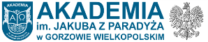
prof. dr hab. ElżbietaSkorupska-Raczyńska
Rector of the Academy Jakub from Paradyż
in Gorzów Wielkopolski

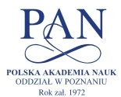

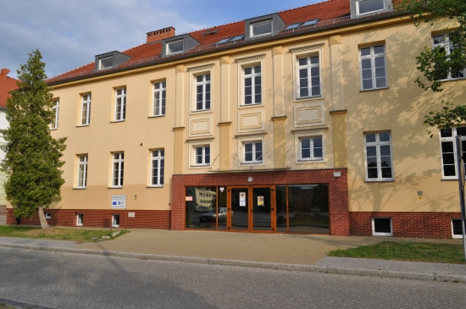

CONFERENCE PAGE:
www.konferencja-swb.ajp.edu.pl

CONTACT:
Academy Jakub from Paradyż in Gorzów Wielkopolski
The economic department,
ul. Chopin 52,
66-400 Gorzów Wielkopolski
Phone: (+48) 95 721 60 15
Email:
konferencja.swb@gmail.com