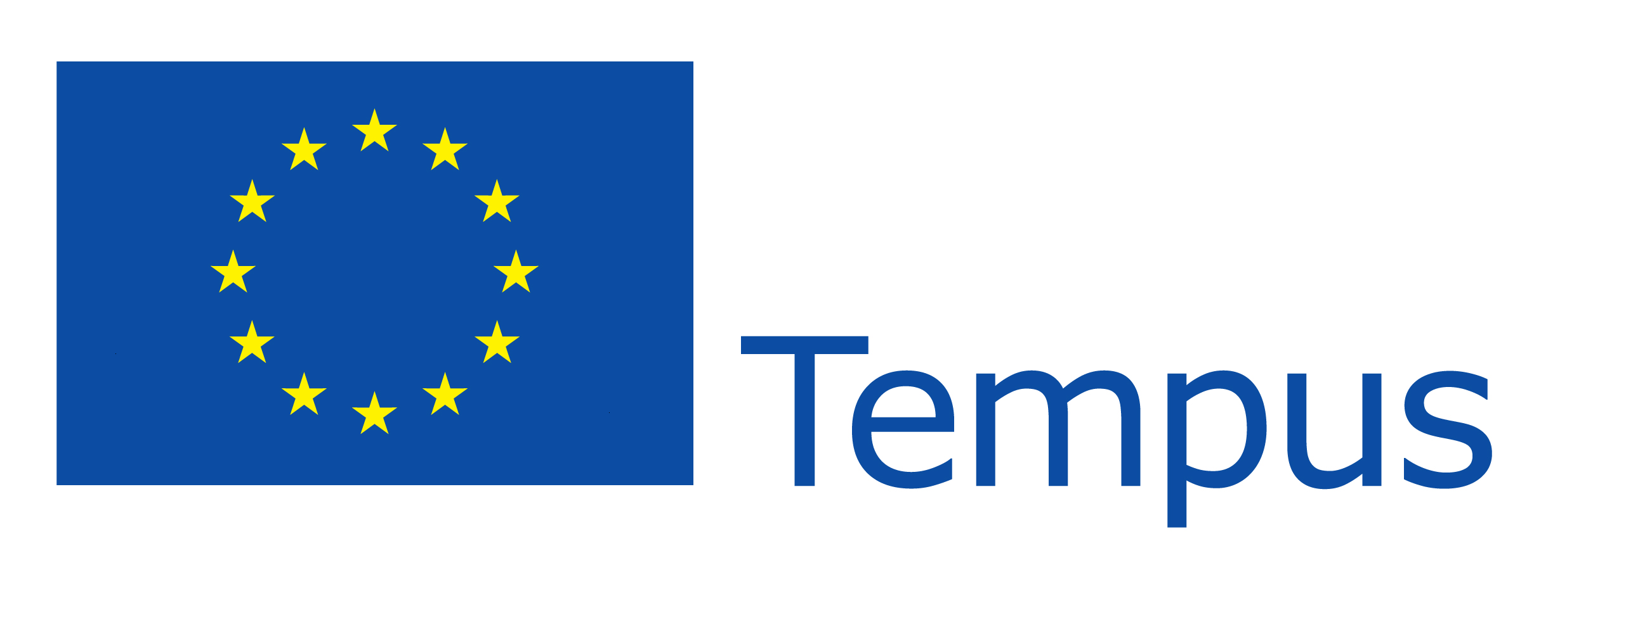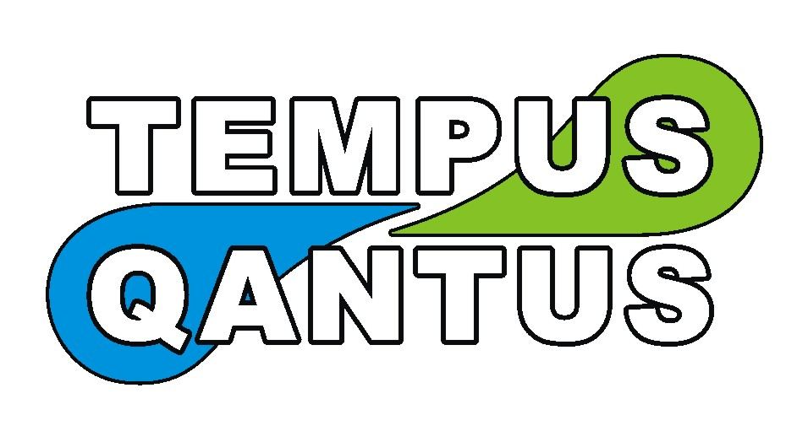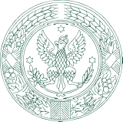

544524-TEMPUS-1-2013-1-PL-TEMPUS-SMHES „ Qualifications Frameworks for Environmental Studies at Ukrainian Universities –QANTUS”, Warsaw 11-17 June 2017.

Sunday, June 11, 2017
Arrival of participants

Monday, June 12, 2017

9:00 – 12:00 Welcome and introduction, presentation by prof. Józef Mosiej (Faculty of Civil and Environmental Engineering, building 33)

12:00 - 13:00 Visit to bank

Tuesday, June 13, 2017

09:00 - 11:00 Steering Committee meeting (Prof. S. Ignar, , Prof. Vadym Zakharchenko, Prof. Sergiy Stepanenko, Prof. Ganna Titenko, Mr. Oleg Shabliy, , MSc Monika Techmanska-Jastrzebska):administrative issues, budget, documents (Faculty of Civil and Environmental Engineering, building 33)

09:00 - 11:00 Parallel action – Tour around University (SGGW history, infrastructure, library, auditoriums, laboratories, facilities, etc) for study visit participants;

11:00 - 14:00 Sightseeing of Water Center

Wednesday, June 14, 2017

10:00-12:00 Steering Committee meeting (Prof. S. Ignar, Prof. Marek Frankowicz, Prof. Vadym Zakharchenko, Prof. Sergiy Stepanenko, Prof. Ganna Titenko, Mr. Oleg Shabliy, MSc Monika Techmanska-Jastrzebska) (Faculty of Civil and Environmental Engineering, building 33)
12:00 – 13:00 Meeting with Marek Frankowicz and discussion about project merithorical issues, results, outcomes, further steps, work already done (Meeting for whole group) (Faculty of Civil and Environmental Engineering, building 33)
13:00 – 14:00 Lunch
14:00 – 17:00 Continuation of meeting with Marek Frankowicz

Thursday, June 15, 2017
Free day

Friday, June 16, 2017
10:00 – 13:00 Meeting with Prof. Sławomir Podlaski (Faculty of Agriculture, building 37)

Saturday, June 17, 2017
Departure of participants

